- Format an SD card in a special way(pls follow the steps,otherwise the screen may crash)
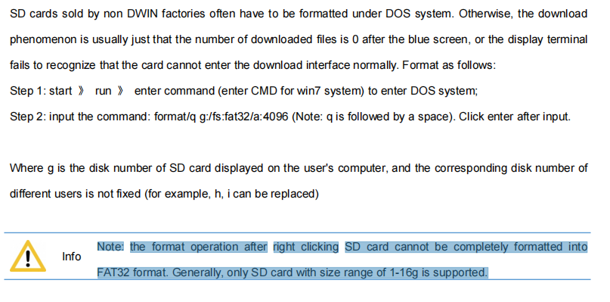
format/q g:/fs:fat32/a:4096
(where g is the disk number of SD card displayed on the user’s computer,and the corresponding disk number of different users is not fixed ,for example ,h,i,e can be replaced)
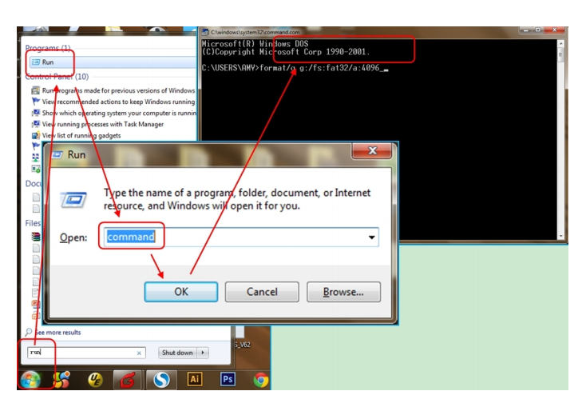
- turn off printer (Power must be turned off )
- Copy DWIN_SET folder to sd card root directory
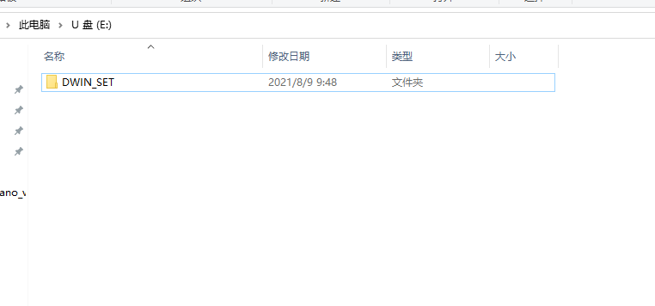
- Remove the screen cover and insert the card into the screen card slot
- Turn on power ,it will automatically refresh.
- When the “End” appears on the screen, turn off power and remove the card
